UML Activity Diagram for Access project

- Login
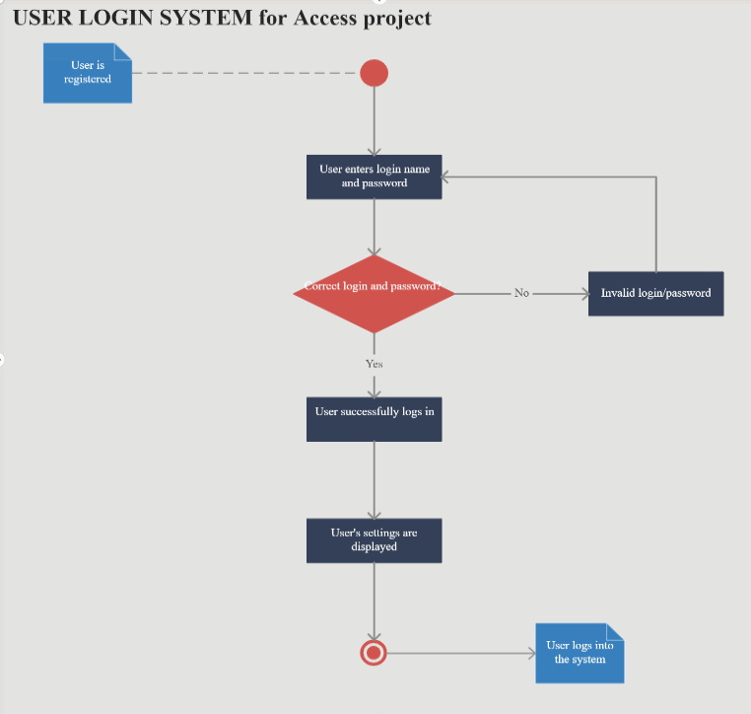
- Find the

